1. Create 2 tables. The first table shows how many salespeople have attrition. Store this information in a column called “attrition”.

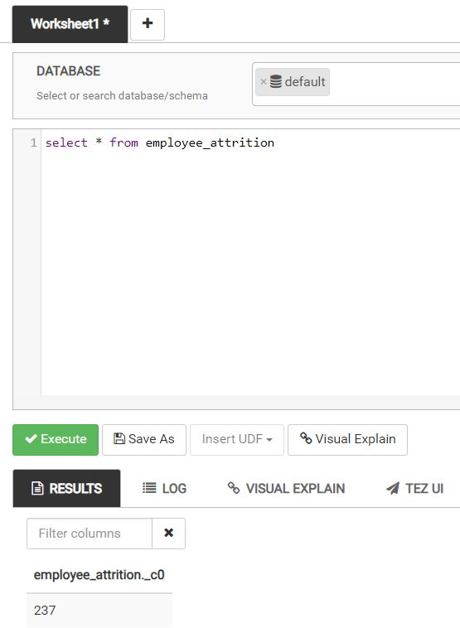

The second table counts how many salespeople have no attrition. Store this information in a column called “Non Attrition”.

2) Create 3 statistics tables (average, min, max) showing the monthly income for: all salespeople, those with attrition and those without attrition. For each table, label the columns “average_monthly_income”, “min_monthly_income”, and “max_monthly_income”.

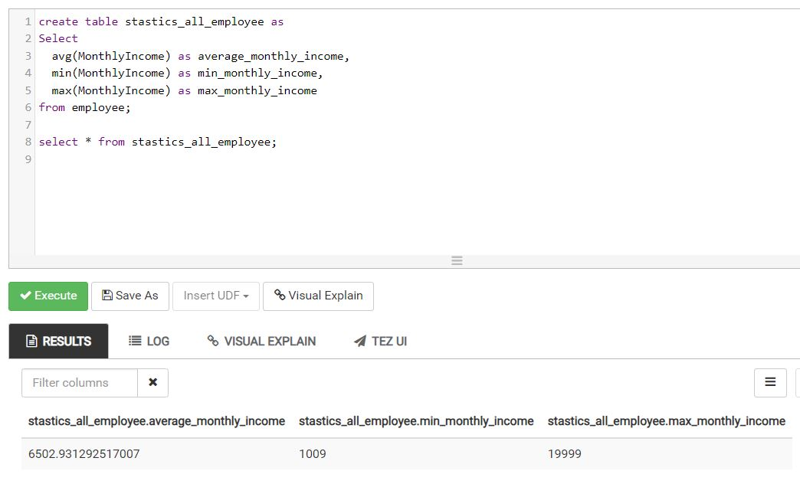

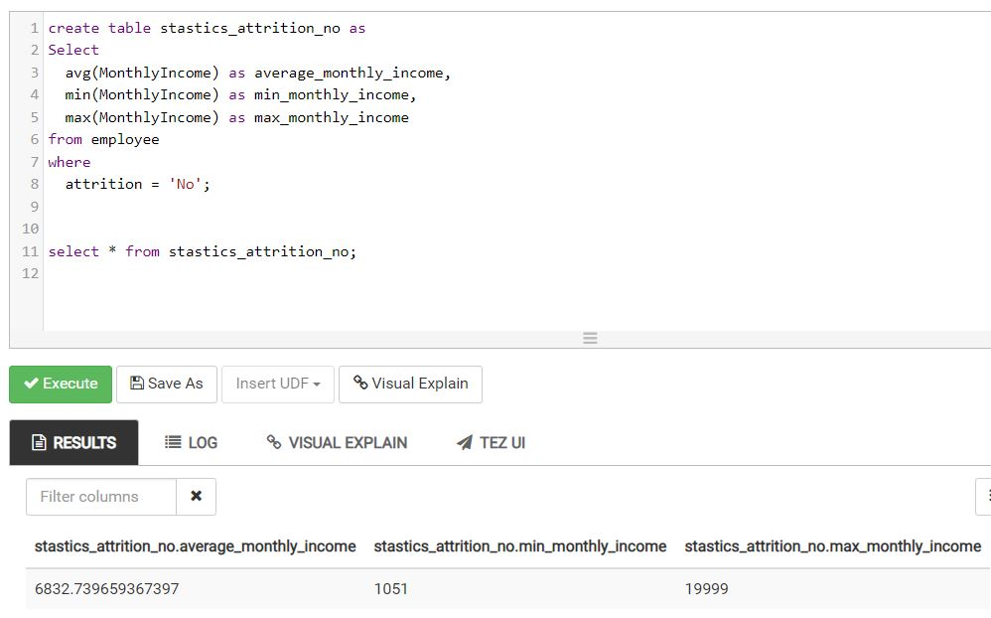

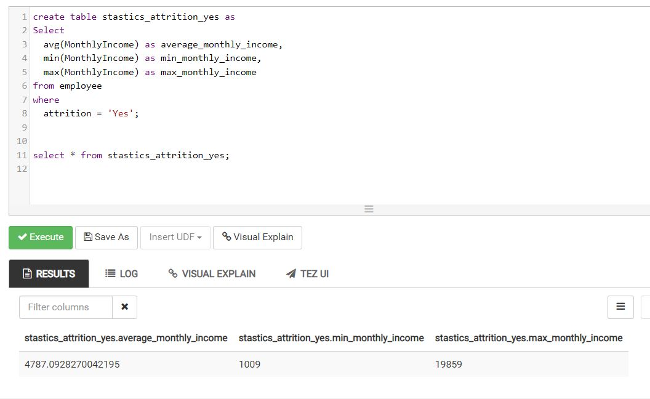

3) Create 2 tables containing the monthly income and count of salespeople making that monthly income for: salespeople with attrition and salespeople without attrition. Label the columns as: “monthlyincome” and “count”

